CyDAQ

Getting Started Guide

sdmay18-31

Table of Contents

Basic Structure 2

Navigation Buttons 3

ADC Configuration 4

Digital Filter Configuration 6

Data Collection Screen 7

Digital Filtering 8

# Basic Structure

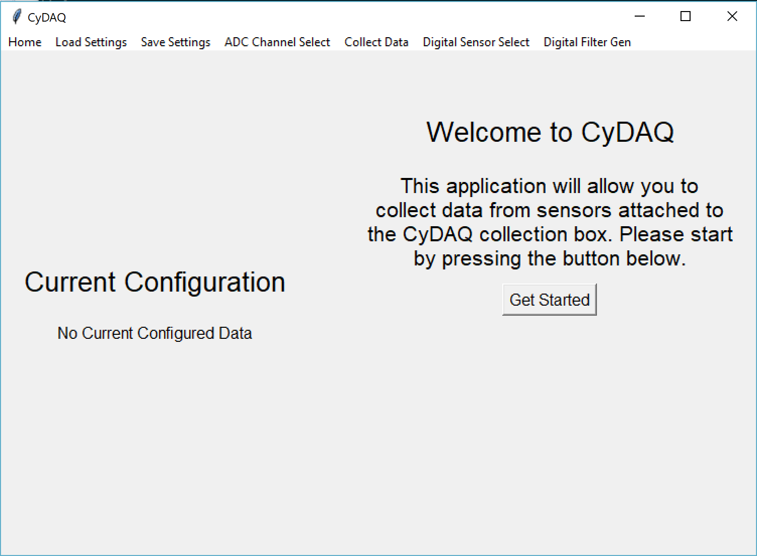

**1**

**3**

**2**

**2**

1. Left Panel: Displays the current sensor configuration that will be loaded onto the CyDAQ hardware. Updated as the settings are configured.
2. Right Panel: Primary user interaction panel. Panel contents gets changed as the user moves through levels of the UI.
3. Navigation Toolbar: Provides navigation buttons to CyDAQ features.

# Navigation Buttons



7

6

5

4

3

2

1

The navigation bar allows the user to change the CyDAQ feature they wish to use.

1. Home, brings the user back to the Welcome Page (Shown Above)
2. Load Settings, launches a prompt for the user to select a settings file (JSON). The stored settings will be loaded into the current CyDAQ session.
3. Save Settings, launches a prompt for the user to save the current CyDAQ settings to a file for future use. Stored as a JSON file.
4. ADC Channel Select, launches the analog sensor configuration screen.
5. Collect Data, launches the data collection screen.
6. Digital Sensor Select, launches the digital sensor configuration screen.
7. Digital Filter Gen, launches the digital filtering screen.

# ADC Configuration

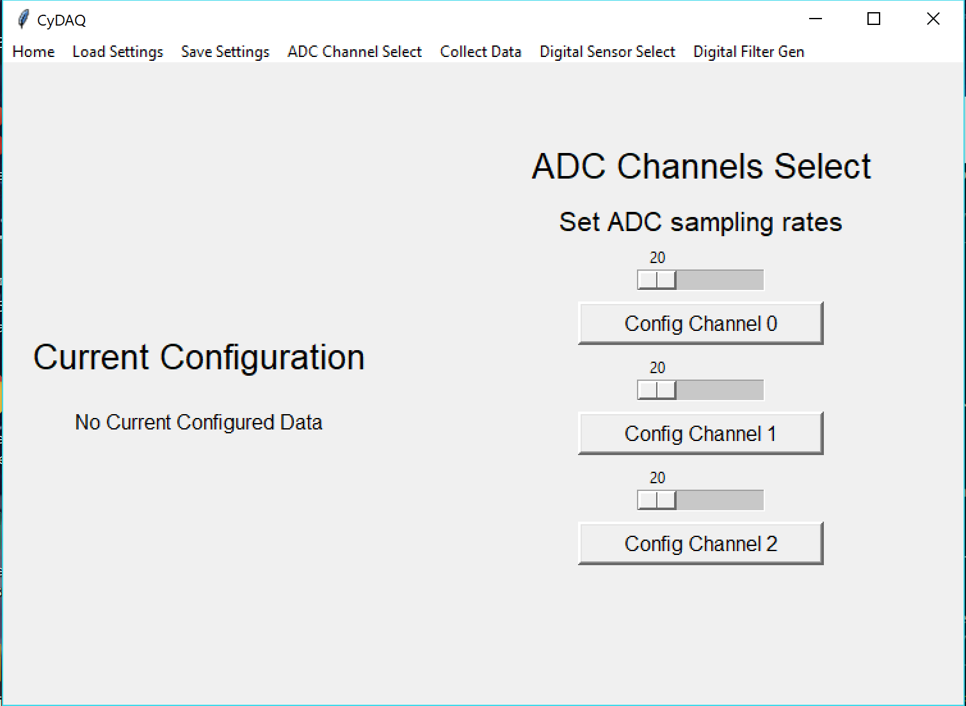

2

1

The CyDAQ device has three ADC channels that can be used simultaneously. The device is limited to a max collective sampling rate of 8000 samples per second. An example of a valid ADC configuration: ADC0 = 200 samples per second, ADC2 = 3000 samples per second.

1. Slider: Sets the sampling rate for an ADC channel. Restricted to a range between 20 and MAX_VAL, where MAX_VAL is 8000 – the sampling rate currently configured for all other analog sensors.
2. Button: Configures the indicated ADC channel with the sampling rate indicated by the slider above the button. Launches the filter path configuration page.

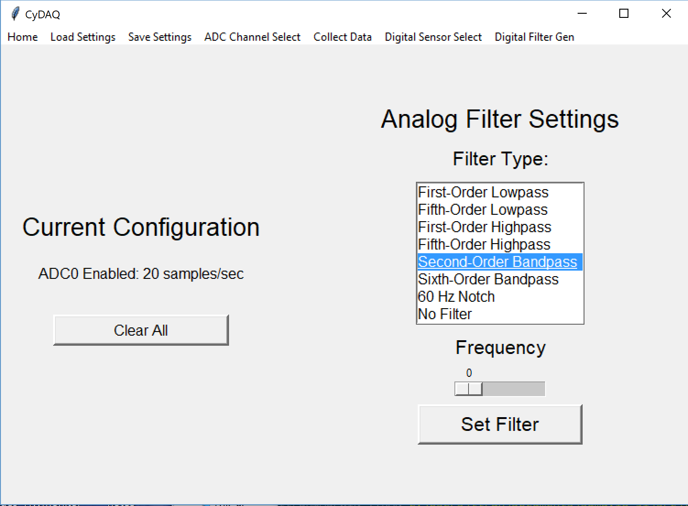

5

3

4

2

1

The above page configures the filter route for the current ADC channel, indicated by arrow 5. Each ADC channel can be configured to route through one of eight analog filter paths on the CyDAQ device. For all paths, beside the “60 Hz Notch Filter” and the “No Filter” path, a frequency setting must be provided. For the highpass and lowpass filter, the frequency is a corner frequency. The frequency setting for the bandpass filters are a corner frequency.

1. List of available filter paths. If another channel is configured to use a path, that filter will be removed from the list.
2. Clears the current configuration that will be sent to the firmware.
3. Frequency adjustment slider, allows frequency adjustments between 0 and 8000.
4. Applies the filter configuration settings to the ADC channel under configuration.
5. Current ADC channel under configuration.

# Digital Filter Configuration

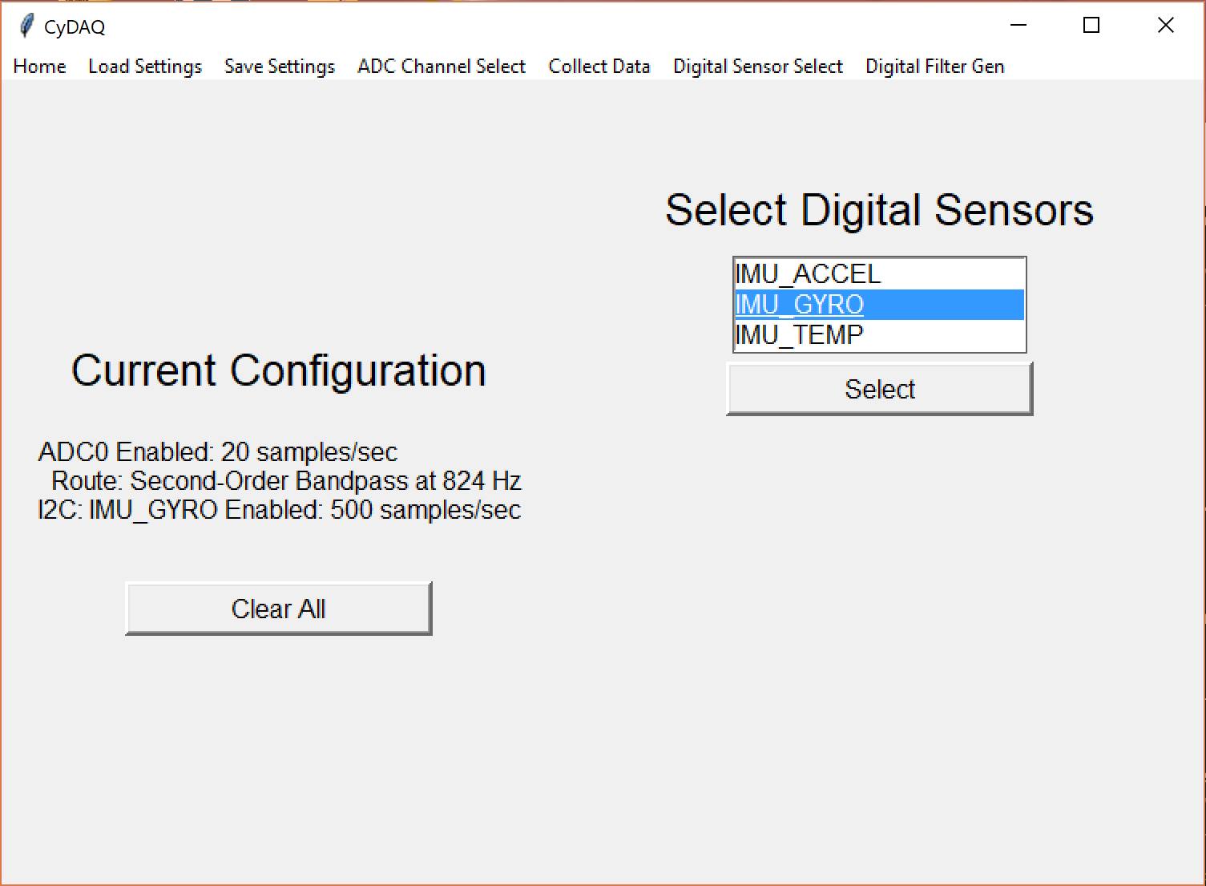

4

3

1

2

The digital sensor configuration page allows a user to select a digital sensor to use. Since the CyDAQ device has two digital sensor ports, one for SPI and one for I2C, a user can have 1 of each type of sensor configured simultaneously. These sensors have fixed sampling rates.

1. List of available digital sensors.
2. Button: applies the digital sensor setting.
3. Settings text indicates that I2C port is set for the IMU_GYRO sensor.
4. Clears the current configuration that will be sent to the firmware.

# Data Collection Screen

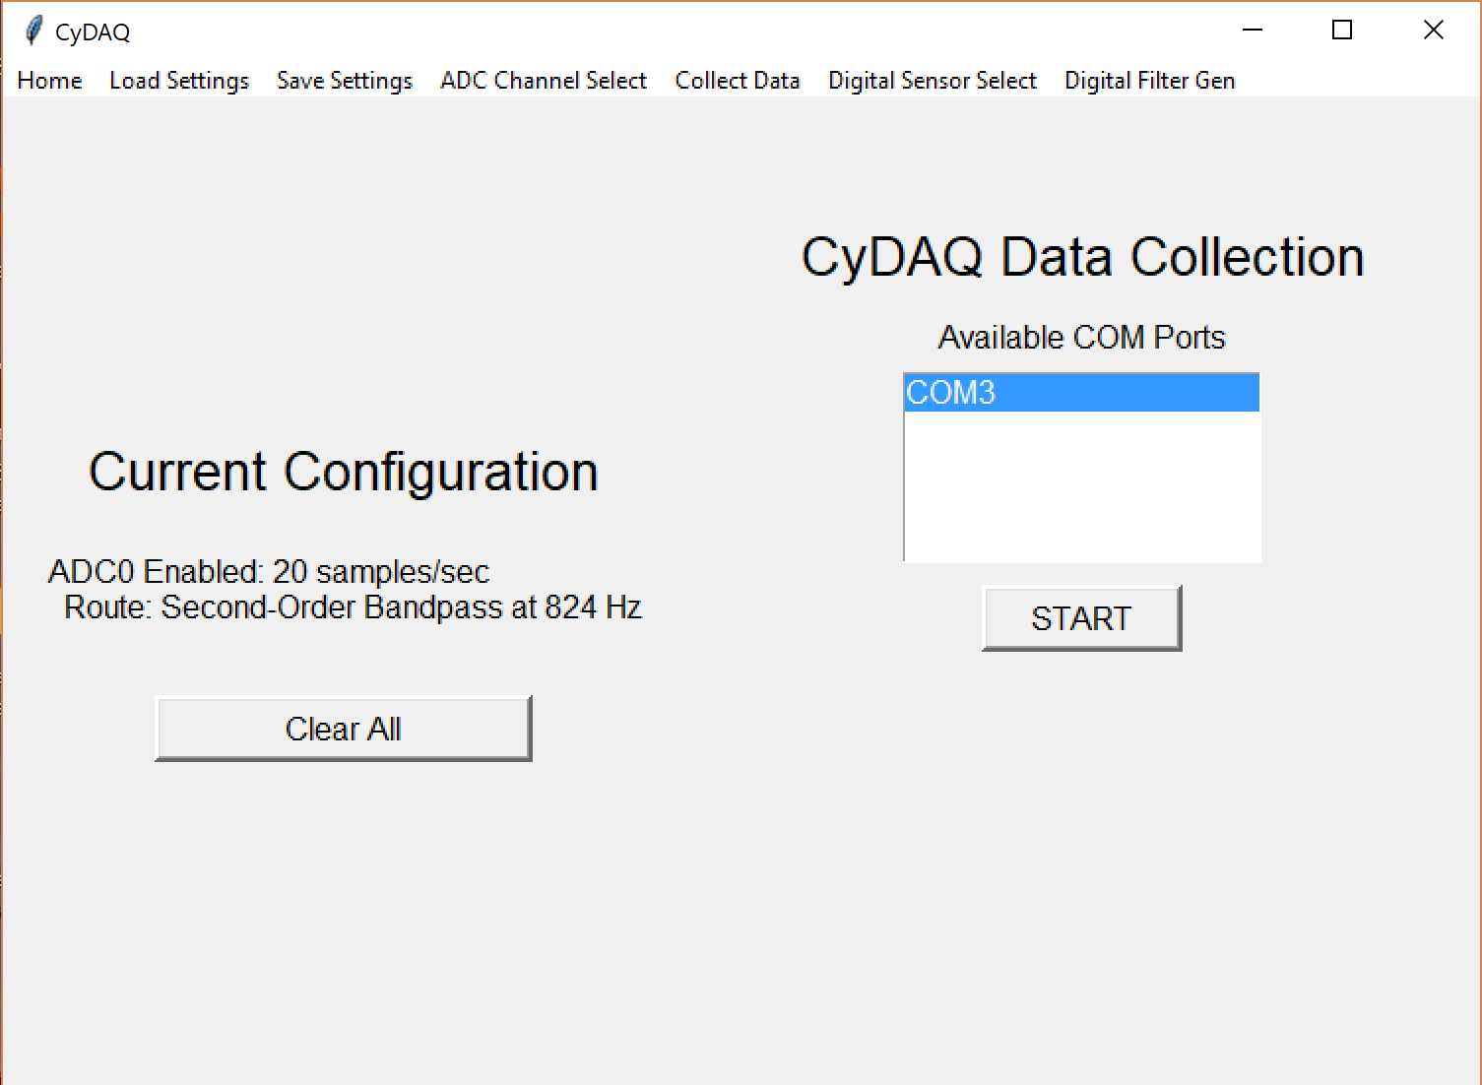

3

2

1

The data collection screen allows the user to select a USB device to collect data from. If there is more than 1 COM port in the device list, the user will need to find the correct CyDAQ device (Stellaris) from the Device Manager. Once the user starts the data collection, the configuration data will be sent to the CyDAQ device, and the device will poll data with the configured settings until the user hits the stop button. Once the user hits the stop button, a File Explorer prompt will show up allowing the user to save the collected data to a CSV or MAT file. A prompt will be given for each sensor configured.

1. List of available COM ports attached to the lab computer, will update periodically as devices are removed and added.
2. Start/Stop Button: Starts and stops data collection. Stopping collection will launch a file save prompt.
3. Clears the current configuration that will be sent to the firmware.

# Digital Filtering

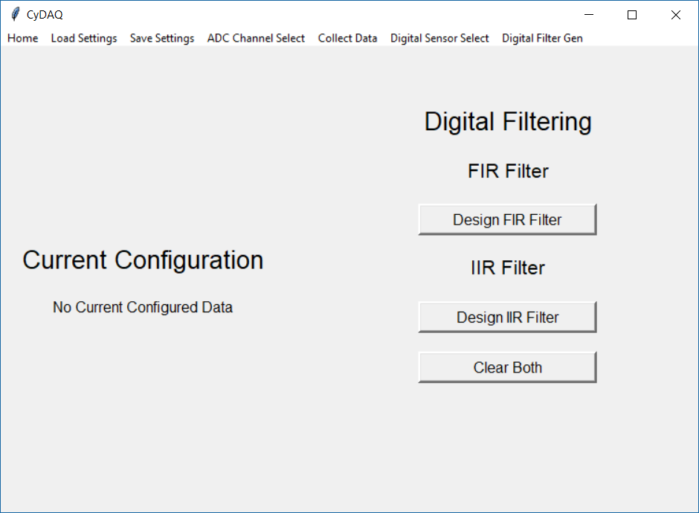

3

1

2

The digital filtering screen allows a user to open a CyDAQ data file, formatted as a MAT or CSV, and perform digital filtering on the stored data. It allows the user to select and design either a IIR or FIR filter.

1. Button, launches a prompt for the user to select an input file, then launches the FIR filter design page.
2. Button, launches a prompt for the user to select an input file, then launches the IIR filter design page.
3. Clears the current digital filtering settings.

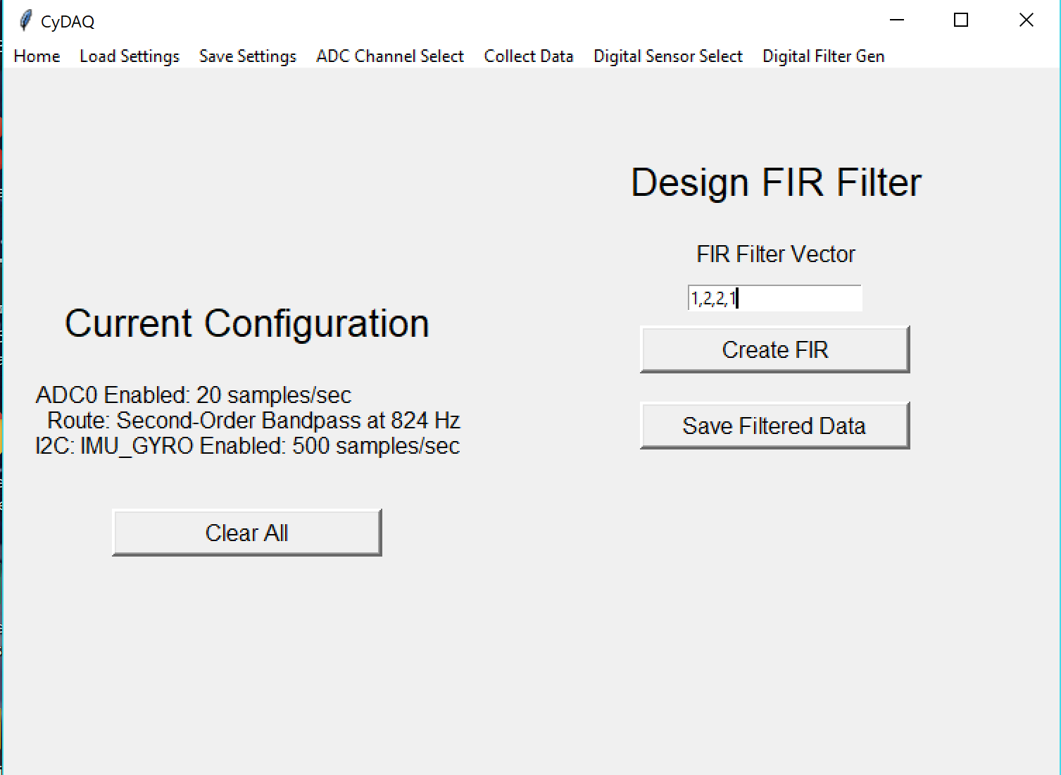

3

2

1

The FIR filter design page allows the user to input the impulse response of the FIR filter they want to design. Once the coefficients are provided, the user can create the filter, plot the filter, and plot the filtered signal. The user can also save the filtered data to a MAT or CSV file.

1. Input Field, allows the user to input FIR filter coefficients as a series of comma separated values.
2. Button, designs a filter with the given coefficients, plots the filter response, and plots the filtered signal.
3. Button, saves the last filtered signal.

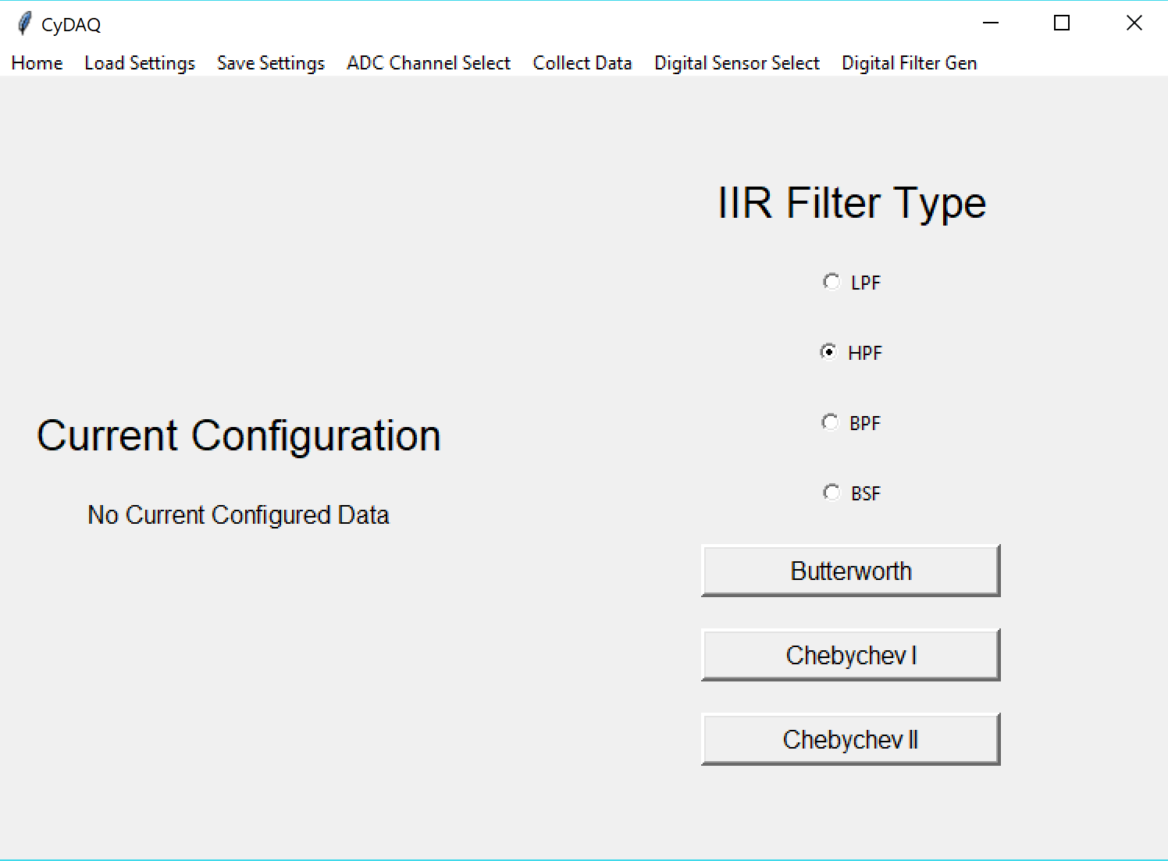

2

1

The IIR filter selection field allows a user to select the type of filter they wish to design. They can select Low-pass, High-pass, Band-pass, or Band-stop filters. They also must select the type of characteristics they wish their filter to take on, such as a Butterworth filter or a Chebychev filter.

1. Choice Buttons, selects the type of filter the user wants to design.
2. Buttons, selects the filter characteristics that the user want their filter to take on, such as maximizing response flatness in the passband (Butterworth). Launches the frequency selection screen.

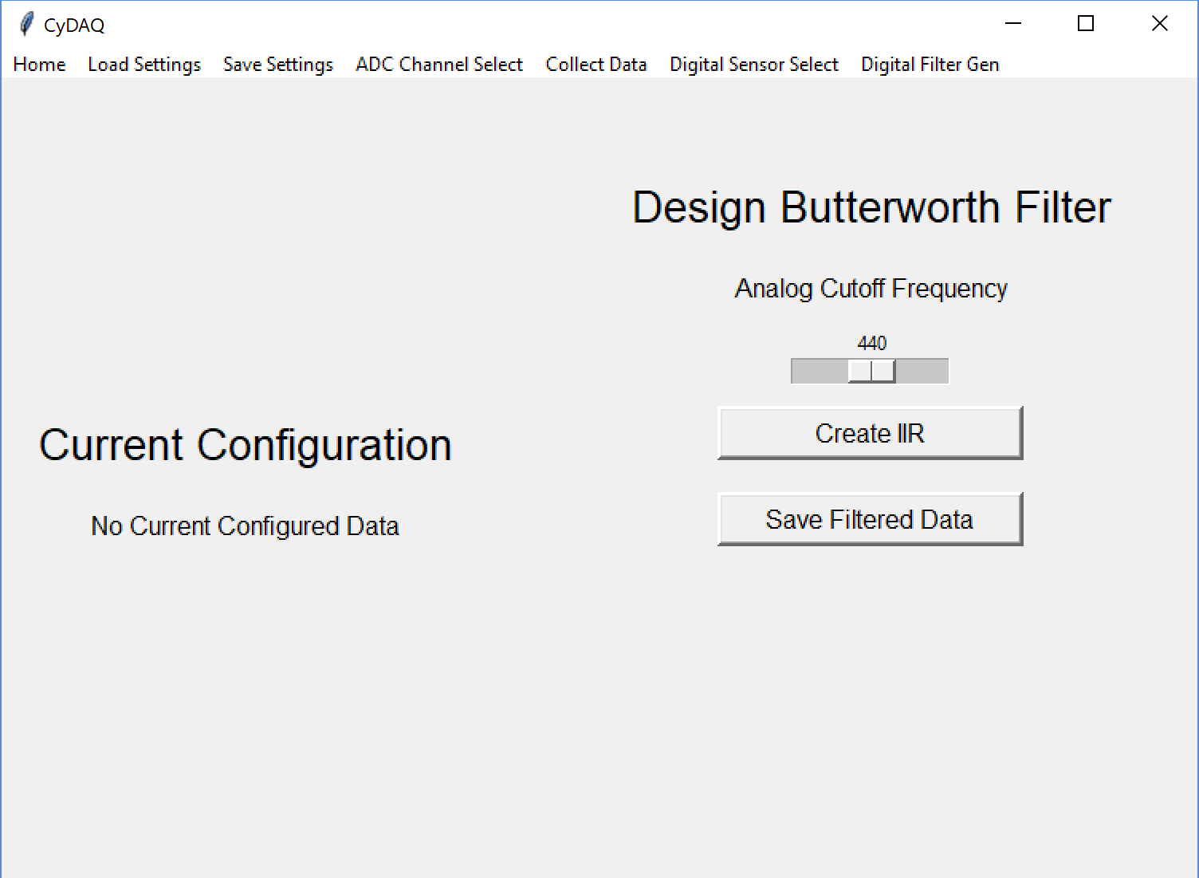

3

2

1

The IIR filter design page allows the user to select the corner/center frequency for the IIR filter they are designing. Once a frequency is selected, the user can create the filter, plot the filter, and plot the filtered signal. The user can also save the filtered data to a MAT or CSV file.

1. Slider, allows the user to select the corner/center frequency for their IIR filter.
2. Button, designs a filter with the given frequency, plots the filter response, and plots the filtered signal.
3. Button, saves the last filtered signal.